Fisels AD Account Sync Automation

Process Definition Document (PDD)

CONFIDENTIAL

TABLE OF CONTENTS
1. Document Control
1.1 Version Control
1.2 Document Review and Sign-Off
2. General Process Description
2.1 Document Purpose
2.2 Process Summary
2.3 Applications Used
2.4 Inputs and Outputs
2.5 High-Level Process Flow
3. Exception Handling
3.1 Known Exceptions
3.2 Unknown Exceptions
4. Step-by-Step Process Documentation

1. DOCUMENT CONTROL
1.1 VERSION CONTROL
Version | Date | Description | Author
1.0 |  | Initial Draft

** Document version should be updated when shared with primary stakeholders. **
1.2 DOCUMENT REVIEW AND SIGN-OFF
Name | Business Role | Action | Date

2. GENERAL PROCESS DESCRIPTION
2.1 DOCUMENT PURPOSE
Here is a possible Document Purpose section:
**Document Purpose**
This document outlines the automated process for syncing Fisels AD accounts with their respective portals (Autodesk and Adobe) using an Excel file as an intermediary. The purpose of this automation is to eliminate manual intervention in updating user licenses and account status, which was previously time-consuming and prone to errors. By automating this process, we aim to improve efficiency, reduce the risk of human error, and enable faster decision-making for our team.
This document will be used by the Fisels AD Account Sync Automation team members, who are responsible for setting up and maintaining the automated processes. It will also serve as a reference guide for new team members or individuals who need to understand the process and its requirements. By following this documentation, users can ensure that the automation is executed correctly, reducing the risk of errors and improving overall productivity.
2.2 PROCESS SUMMARY
**Business Process Summary**
The objective of this business process is to manage user accounts, licenses, and contract data for various companies, including Fisels, Microsoft, Autodesk, and Adobe. The process involves reviewing processes with stakeholders, logging into systems, downloading data from Portal to Excel/CSV files, and using scripts to check account status and update license information.
The main steps of this process include:
1. Logging into the Portal system of Autodesk and Active Directory (AD) to access user account information, license details, and contract data.
2. Downloading data from the Portal to Microsoft Excel or CSV files for further analysis and processing.
3. Using scripts to check the status of user accounts in AD and update license information accordingly.
4. Removing inactive or disabled user accounts from the Portal system based on script output.
5. Validating license information and checking account status in AD to ensure accuracy.
The applications and systems used in this process include Autodesk's Portal, Microsoft Excel, Active Directory (AD), and Auto-test. The data being processed includes user account information, license details, contract data, and user usage data.
The expected outcome of this business process is the accurate tracking of user accounts and licenses across various systems, efficient removal of inactive or disabled user accounts from the Portal, and simplified access to user data for stakeholders. This will enable companies to maintain up-to-date records of user account information and license allocations, ensuring compliance with contractual agreements and optimizing resource utilization.
2.3 APPLICATIONS USED
Application | Interface | Key Operation / URL | Purpose
Microsoft Excel | Desktop App |  | Data management and reporting tool, used to store and update data on user accounts and licenses.
Auto-test | API (mentioned as being accessed from the portal) |  | Automation tool used to check user account status in AD and update Excel file accordingly.
Adobe (portal) | Web Browser (logged in through email ID) |  | Portal for managing licenses, users, and subscriptions, accessed via a web browser after logging in with an email ID.

2.4 INPUTS AND OUTPUTS
Inputs:
➤ No specific inputs identified
Outputs:
➤ No specific outputs identified

2.5 HIGH-LEVEL PROCESS FLOW
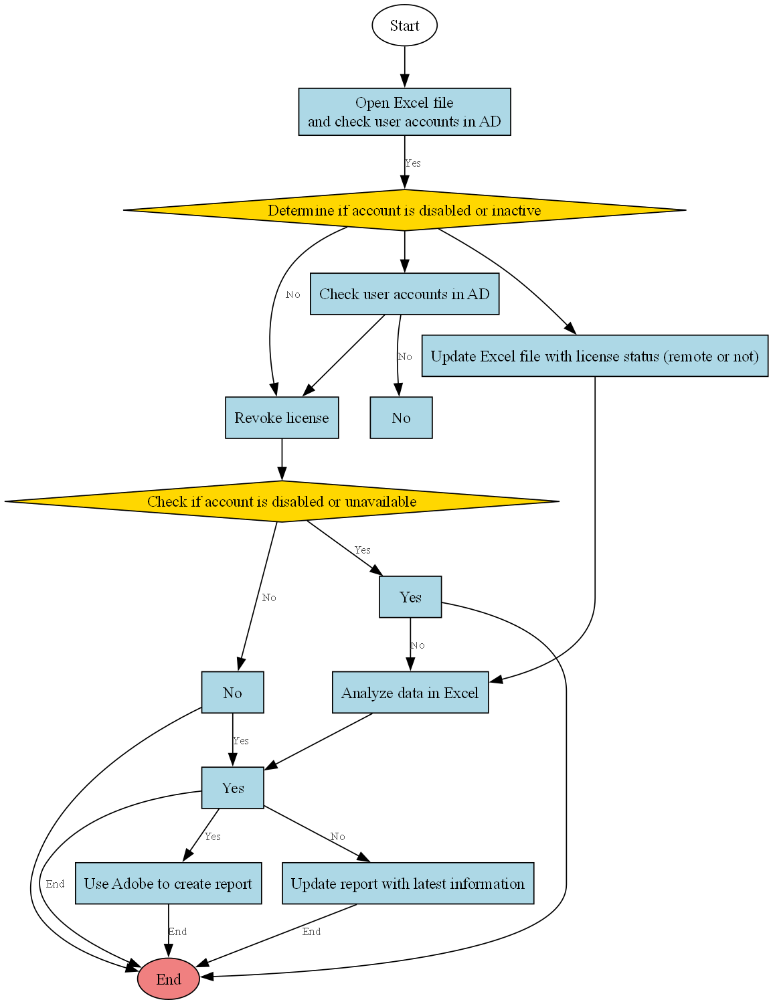
Figure 1: Fisels AD Account Sync Automation Process Flow

3. EXCEPTION HANDLING
This section documents the different types of exceptions that may occur during process execution and how they should be handled.
3.1 KNOWN EXCEPTIONS
The following table lists process exceptions that have been identified and their corresponding handling procedures:
Exception Code | Description | Handling Action
EXC_001
EXC_002
EXC_003

3.2 UNKNOWN EXCEPTIONS
Unknown exceptions are errors that may occur during processing that were not previously identified. These will be logged and escalated according to the standard exception handling procedure.
Exception Code | Description | Handling Action
ERR_UNKNOWN | Unexpected system error | Log error, notify support team
ERR_TIMEOUT | Application timeout | Retry operation, escalate if persistent

4. STEP-BY-STEP PROCESS DOCUMENTATION
This section provides detailed step-by-step documentation of the process, including screenshots captured during process execution.
4.1 DETAILED PROCESS STEPS
Step 1

Here are the converted step descriptions:

Step 2
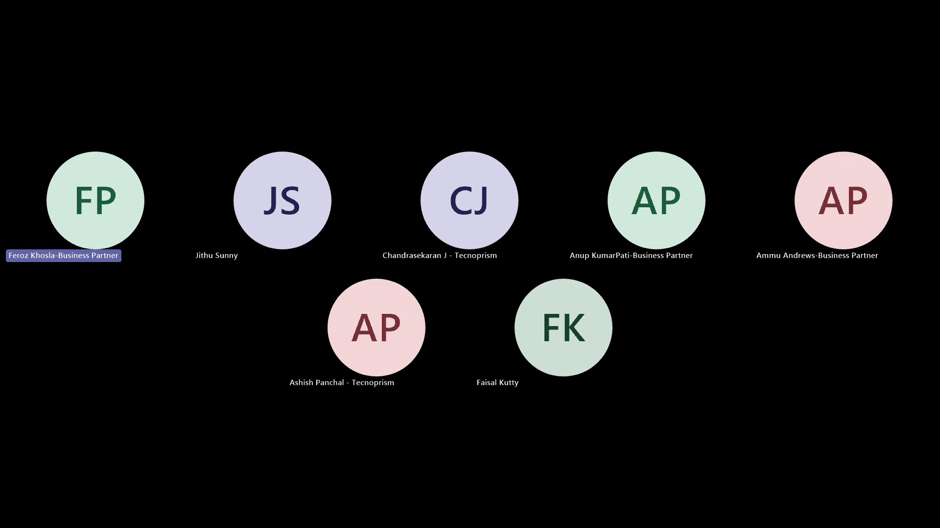
The user schedules a meeting by initiating the scheduling process.

Step 3
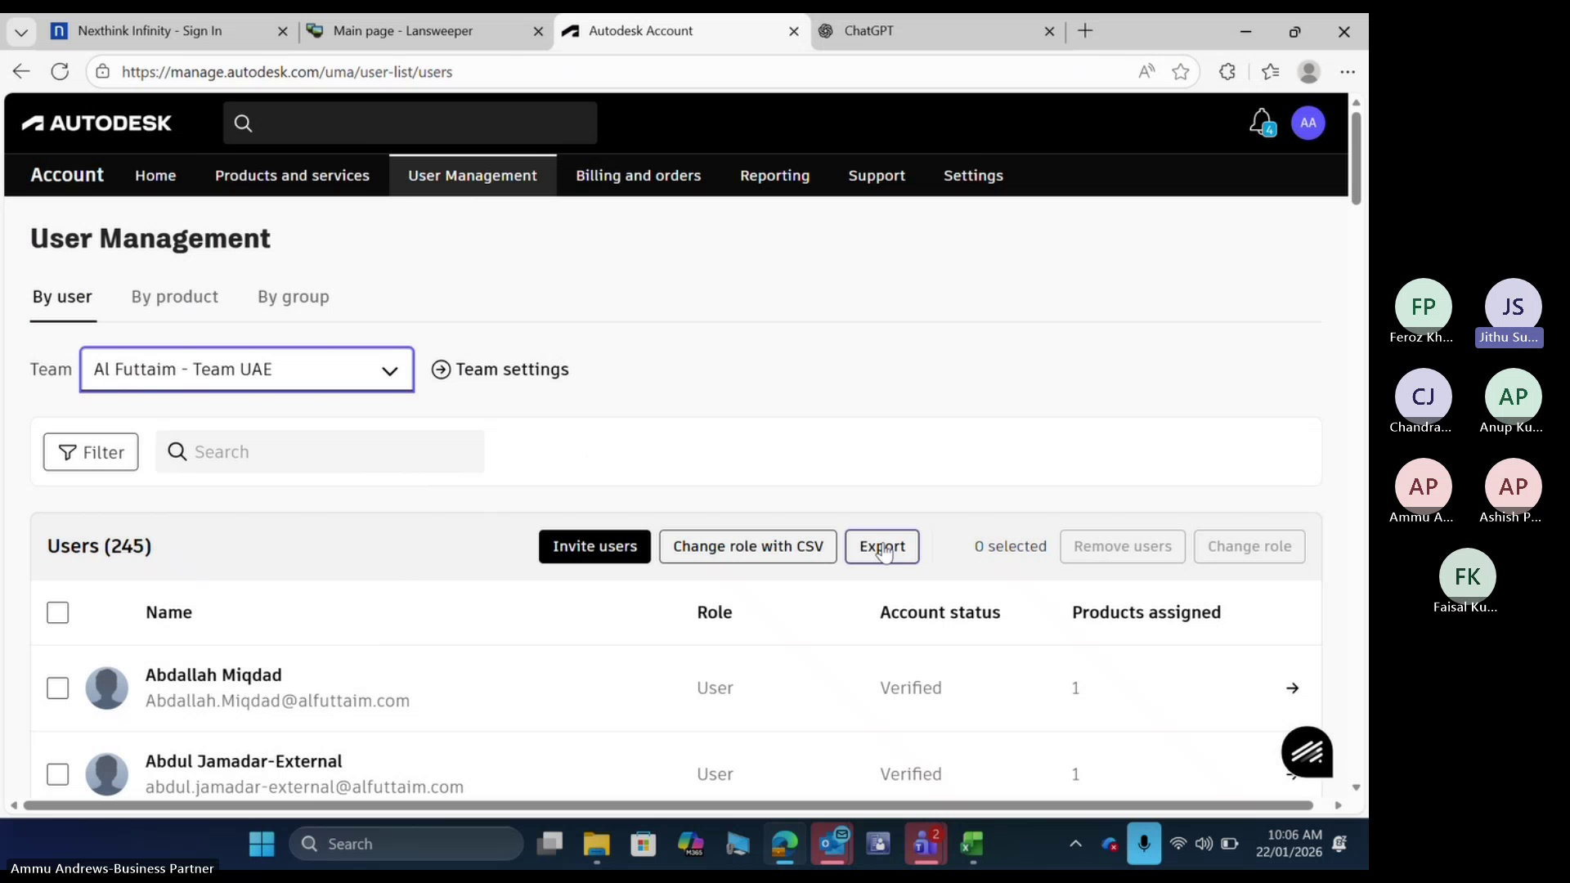
The user views existing results or reports, which can be accessed at any time.

Step 4
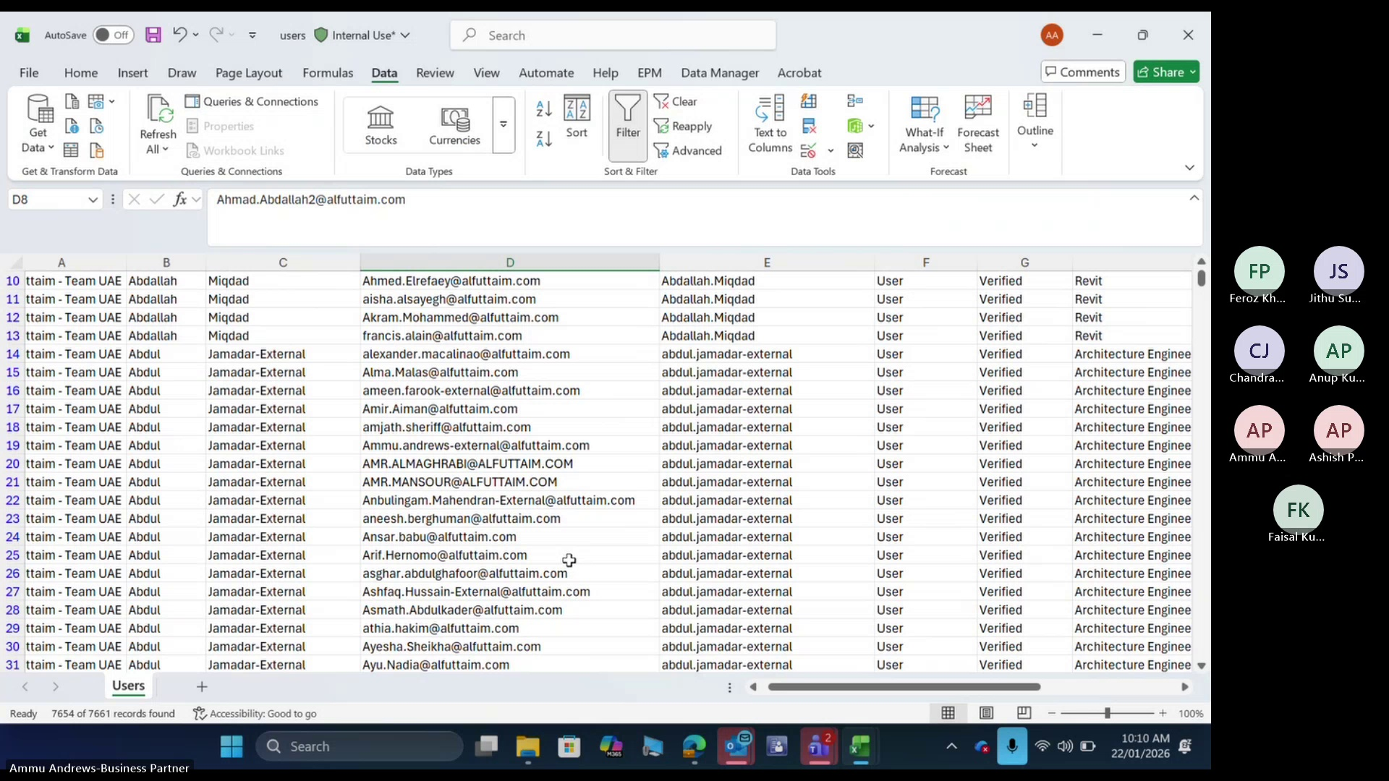
To avoid unintended consequences, the user refrains from clicking on the "Export" button.

Step 5
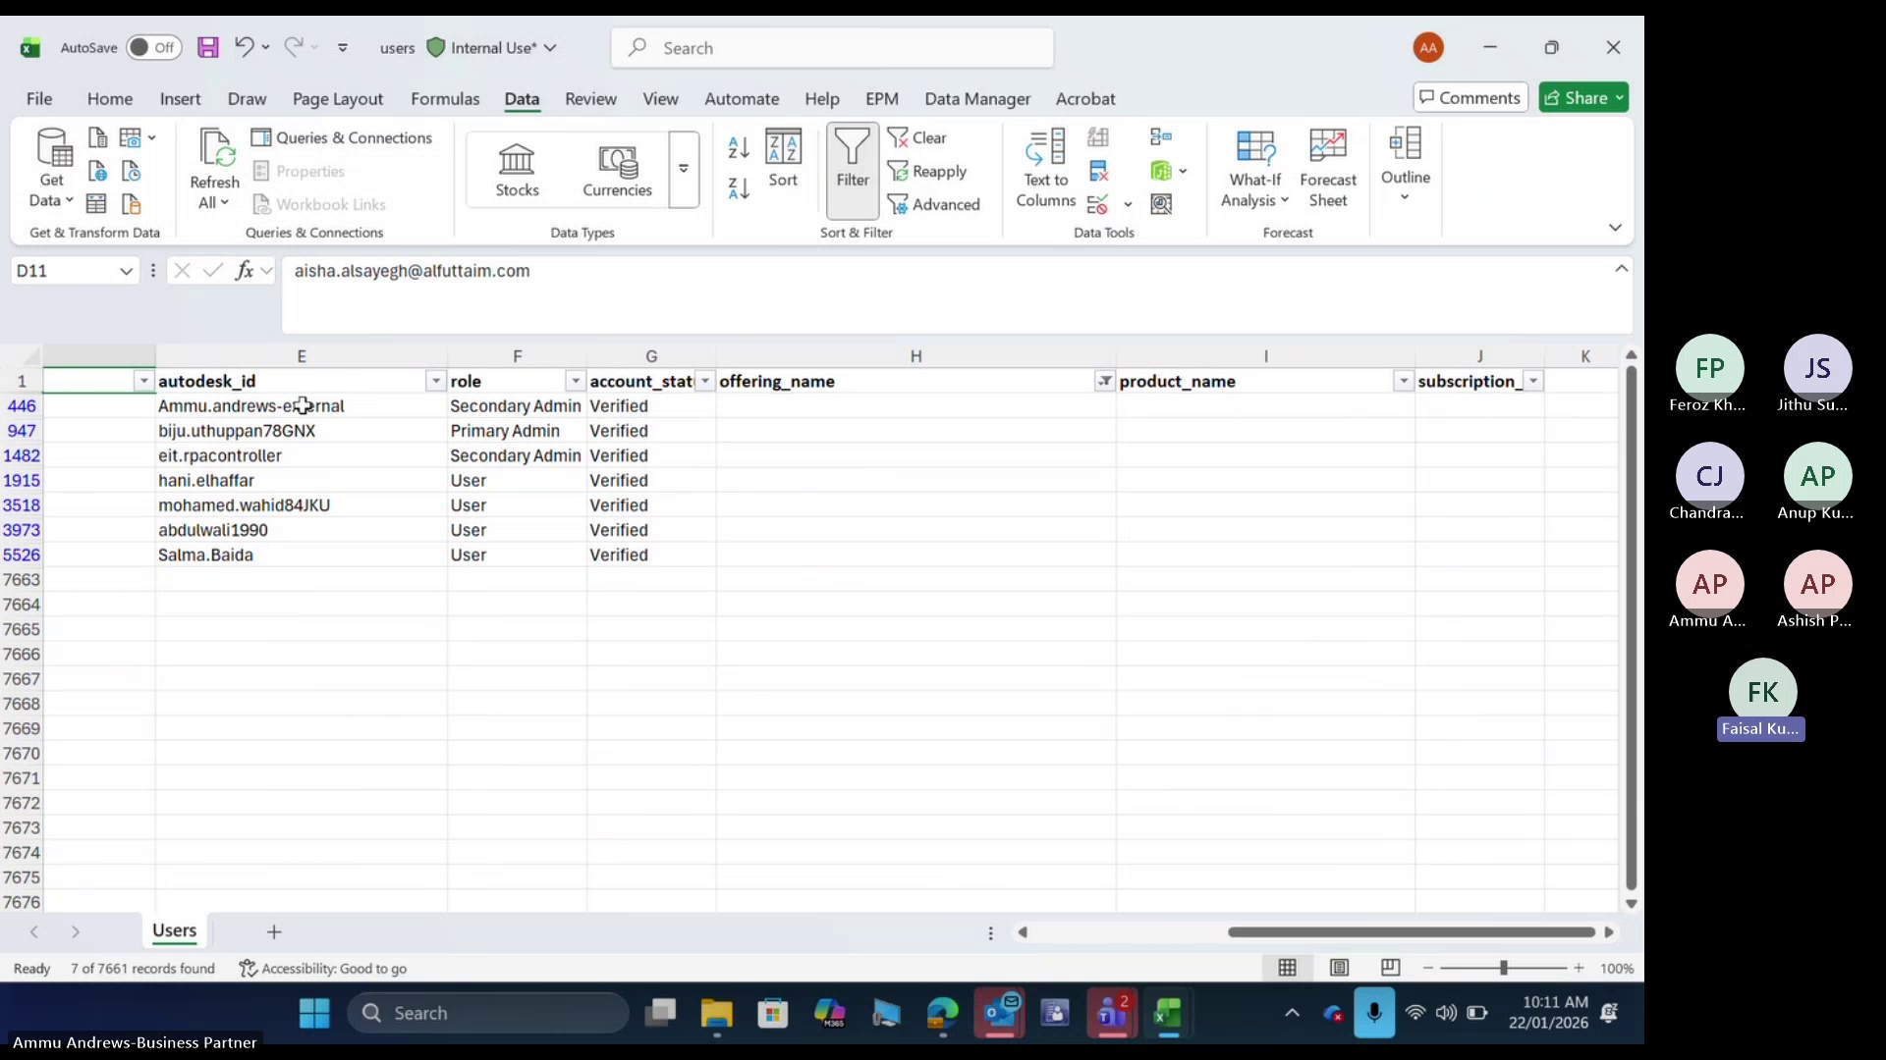
The user reviews and interprets the content within a specific column of the report or result.

Step 6
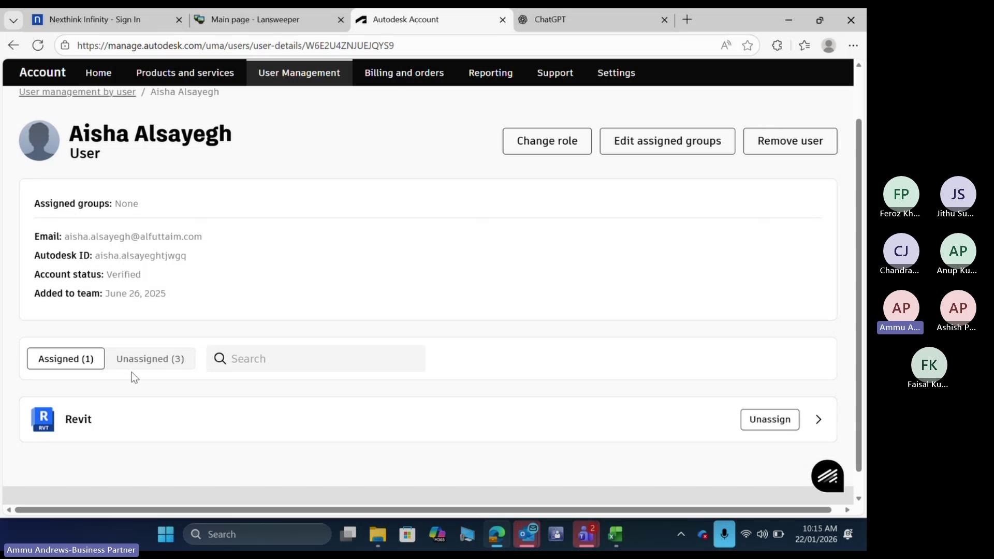
The user accesses information about their own access permissions, including any relevant settings or restrictions.

Step 7
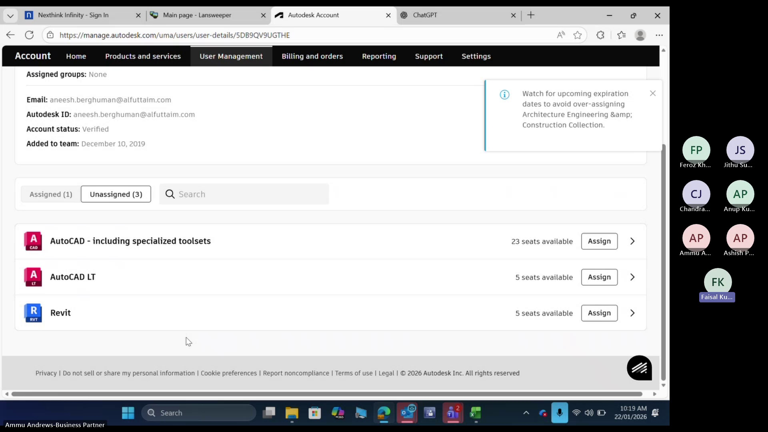
Here are the professional step descriptions:

Step 8
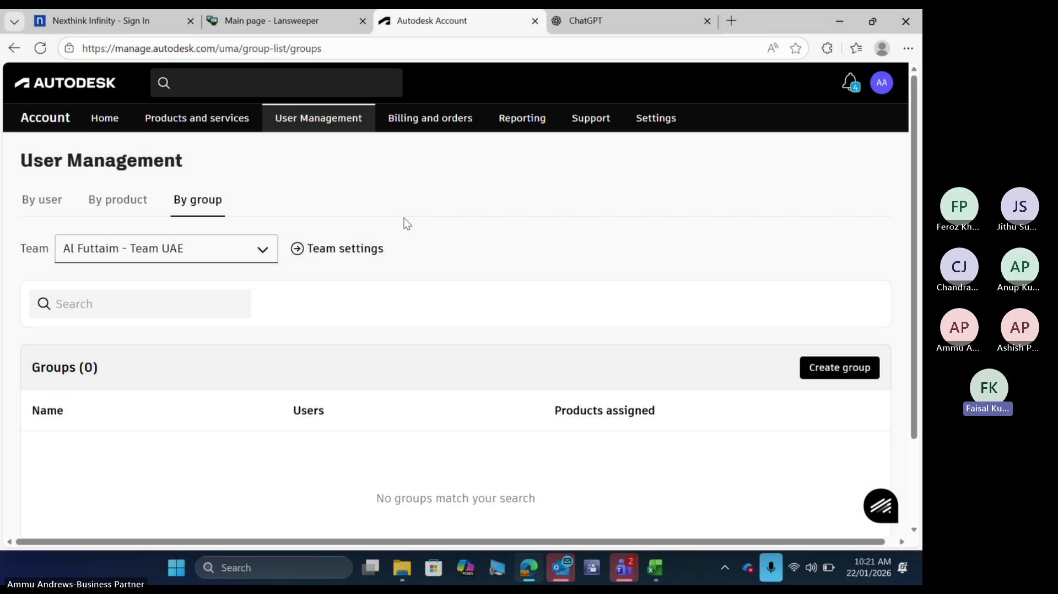
The user must unassign all available items from the list.

Step 9
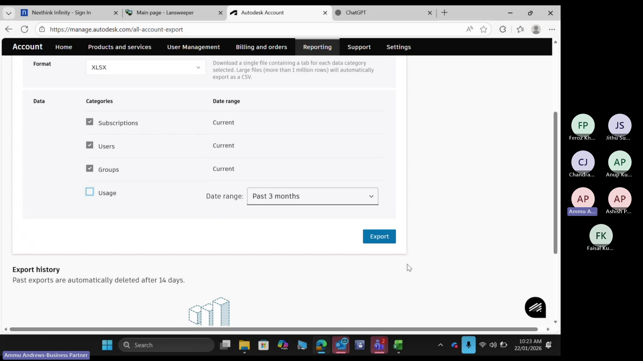
The user will view and manipulate a list for easier allocation of subsequent items.

Step 10
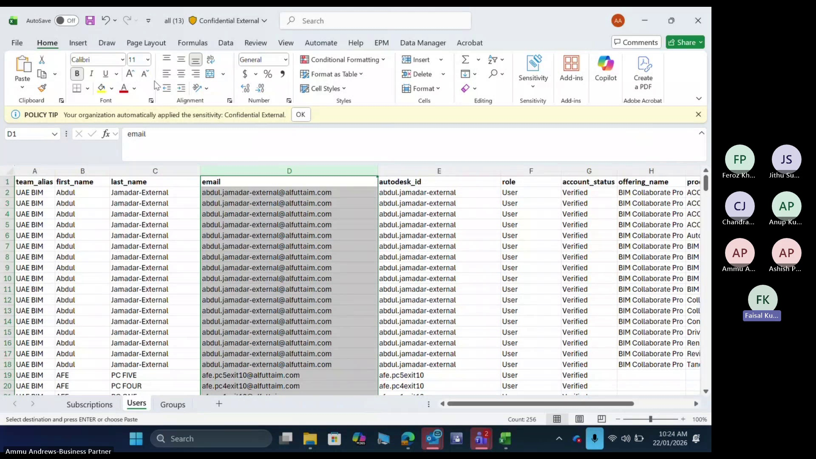
The system displays results or reports, including status updates for each item that went out of cycle across all five categories.

Step 11
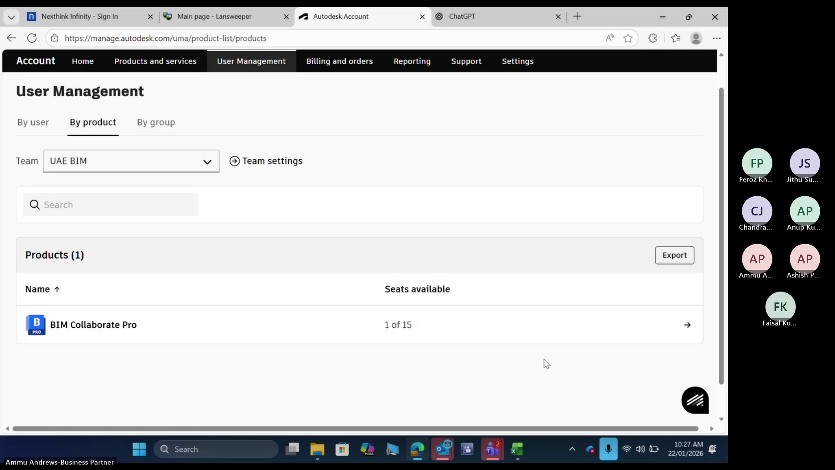
Click on the "Export" button to initiate data transfer.

Step 12
The user views the report to verify accuracy and completion of required tasks.

Step 13
Here are the professional step descriptions:

Step 14
The user navigates to the export function by clicking on the designated button or menu.

Step 15
The user views the results or reports, confirming that they are accessible and ready for review.

